**Cisco Packet Tracer  
Assignment 9**

Create following topology and VLANs on Packet Tracer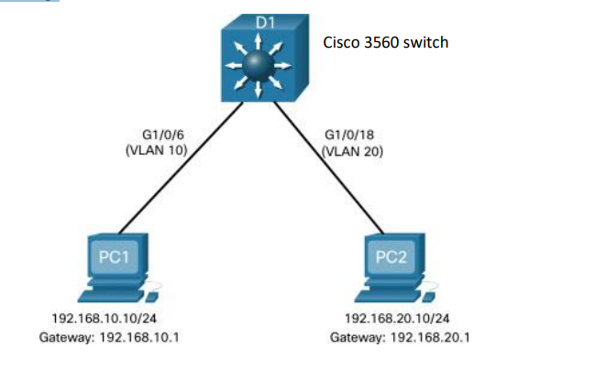  
Correction: Cisco 3650 Switch

Set IP Configuration

See addresses and Gateway from image above

Configure the network for Inter-VLAN routing.

D1(config)# vlan 10

D1(config-vlan)# name VLAN10

D1(config-vlan)# vlan 20

D1(config-vlan)# name VLAN20

Verify the Inter-VLAN Routing using ping utility

Go to PC0 (192.168.10.10)  
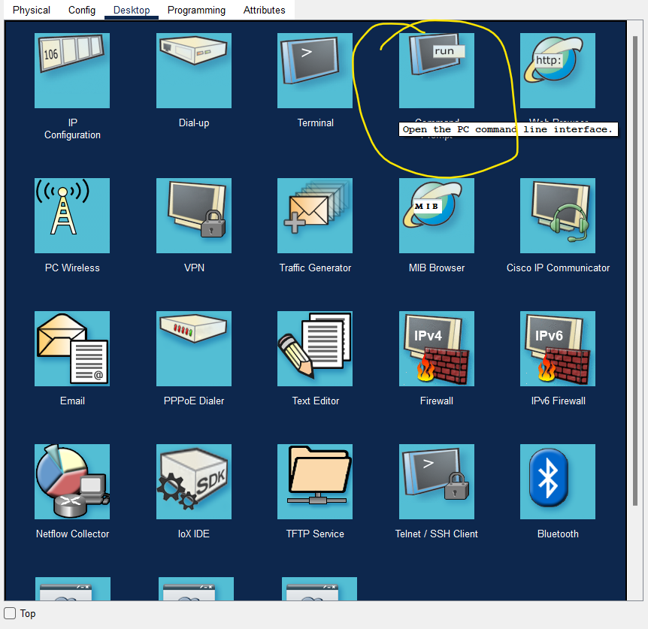

On Pinging

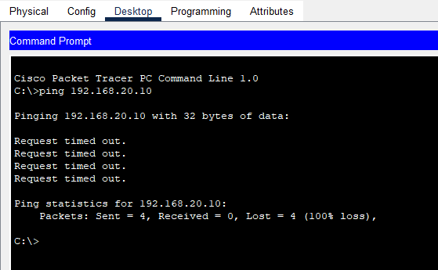

**Layer 3 Switch Configuration**

Create the SVI VLAN Interfaces

D1(config)# interface vlan 10   
D1(config-if)# description Default Gateway SVI for 192.168.10.0/24   
D1(config-if)# ip add 192.168.10.1 255.255.255.0   
D1(config-if)# no shut   
D1(config-if)# exit   
D1(config)#   
D1(config)# int vlan 20   
D1(config-if)# description Default Gateway SVI for 192.168.20.0/24   
D1(config-if)# ip add 192.168.20.1 255.255.255.0   
D1(config-if)# no shut   
D1(config-if)# exit   
D1(config)#

Configure Access Ports

D1(config)# interface GigabitEthernet1/0/6   
D1(config-if)# description Access port to PC1   
D1(config-if)# switchport mode access   
D1(config-if)# switchport access vlan 10   
D1(config-if)# exit   
D1(config)#   
D1(config)# interface GigabitEthernet1/0/18   
D1(config-if)# description Access port to PC2   
D1(config-if)# switchport mode access   
D1(config-if)# switchport access vlan 20   
D1(config-if)# exit

Enable IP Routing

D1(config)# ip routing

**Routing Configuration on a Layer 3 Switch**

Now add a 4331 Router and a Server to get the following topology:

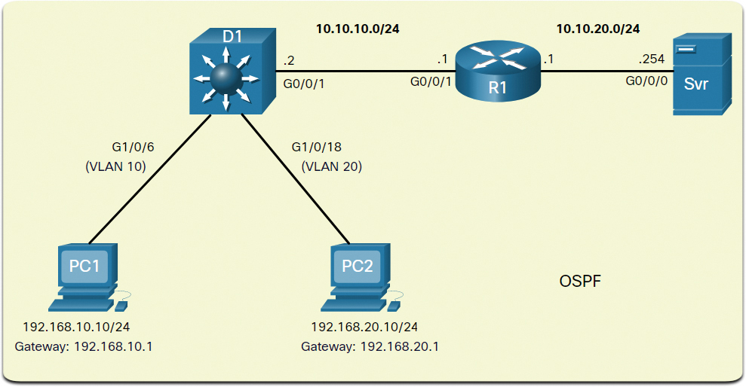

The previously configured D1 Layer 3 switch is now connected to R1. R1 and D1 are both in an Open Shortest Path First (OSPF) routing protocol domain. Assume inter-VLAN has been successfully implemented on D1. The G0/0/1 interface of R1 has also been configured and enabled. Additionally, R1 is using OSPF to advertise its two networks, 10.10.10.0/24 and 10.20.20.0/24.  
  
R1 is using OSPF to advertise its two networks, 10.10.10.0/24 and 10.20.20.0/24.

Router>enable

Router#config terminal

Router(config)#int GigabitEthernet0/0/1

Router(config-if)#ip address 10.10.10.1 255.255.255.0

Router(config-if)#no shutdown

Router(config-if)#exit

Router(config)#int GigabitEthernet0/0/0

Router(config-if)#ip address 10.10.20.1 255.255.255.0

Router(config-if)#no shutdown

Router(config-if)#

Router(config-if)#exit

Enable OSPF on Router

Router>enable  
Router#config terminal  
Router(config)#  
Router(config)#router ospf 1  
Router(config-router)#network 10.10.10.0 0.0.0.255 area 0  
Router(config-router)#network 10.10.20.0 0.0.0.255 area 0

Step 1. Configure the routed port. Configure G1/0/1 to be a routed port, assign it an IPv4 address, and enable it, as shown below(The G1/0/1 interface of R1 has also been configured and enabled)

Configure the Routed Port :

D1(config)# interface GigabitEthernet1/0/1   
D1(config-if)# description routed Port Link to R1   
D1(config-if)# no switchport   
D1(config-if)# ip address 10.10.10.2 255.255.255.0   
D1(config-if)# no shut   
D1(config-if)# exit   
D1(config)#

Enable Routing

D1(config)# ip routing   
D1(config)#

Configure Routing

D1(config)# router ospf 10   
D1(config-router)# network 192.168.10.0 0.0.0.255 area 0   
D1(config-router)# network 192.168.20.0 0.0.0.255 area 0   
D1(config-router)# network 10.10.10.0 0.0.0.255 area 0   
D1(config-router)# ^Z   
D1#

Verify Routing

D1# show ip route | begin Gateway

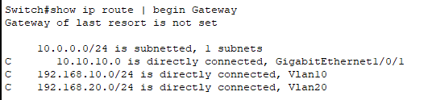

Verify Connectivity

C:\Users\PC1> ping 192.168.20.10